Verbosity

Revision History
Ver. | Date | By | List of changes
1.0 | 05/01/2007 | Max Sogin | Initial

Table of Contents
Revision History 1
Table of Contents 2
Logging instantiating (client side) 3
Verbosity 3
Trace calls 3
Trace states and invariants 3
Trace debug messages 3
No trace 3
Controlling verbosity threshold 3
Severity 4
Log output 4
Format examples: 4
Human readable format: 4
Excel compatible format: 5
Informational field types 5
Informational fields / severity chart 5
Log interface definition 6
Net Log 6
Client 6
Class diagram 6
Server 6
Class diagram 6

Logging instantiating (client side)
To simplify log configuring – singleton log is assumed to be the main log instantiating pattern. This means that each process should own only one main log object, accessible from c++ code in simple way, for example through predefined macro definition Log.
Note: different modules (shared dll) within one process also should use one log object.

Verbosity
In order to support different output levels of debug messages, following verbosities are provided:
- Trace calls
- Trace states and invariants
- Trace debug messages
- No trace
Each higher level should include all lower levels, for example Level 1 (Trace calls) should also output all Level 2 (Trace states and invariants) and Level 3 (Trace debug messages) messages.
Verbosity level can has 2 meanings:
- Log message verbosity level. (Each logging message should has it’s own verbosity level)
- Threshold for messages verbosity level, to filter logging output. (Each process or even all host processes should have one verbosity threshold at one time moment)
For example if we have threshold 2, all messages with 2 and 3 verbosity will be logged. If threshold is set to 3 – only messages with verbosity level 3 will be logged.

Trace calls
Call tracing means that each method entering and return is accompanied by corresponding log messages, containing object and method names.
To provide call tracing prologue/epilogue technique should be used. Since TRY_CATCH CATCH_THROW/CATCH_LOG macro definition already used as prologues and epilogues - the best solution is just minimal modifications to these macro definitions to support call tracing. For example CATCH_THROW and CATCH_LOG should instantiate in stack some helper log object, which in constructor outputs ‘enter method’ message, and in destructor – ‘leave method’ message.

Trace states and invariants
Each object invariant or state change should be logged with corresponding message, containing old and new invariant or state values.
Minimal code amount should be required to perform such traces. For example macro definition TRACE_STATE(name, value, newValue)

Trace debug messages
This level is assumed to be ordinary logging verbosity. All direct calls of log object methods should have this verbosity level. For example Log.Add(_MESSAGE_,…), Log.Add(_ERROR_,…), Log.Add(_WARNING_,…), Log.Add(_EXCEPTION_,…)

No trace
Logging message couldn’t have this verbosity level. This value has sense only as threshold for messages verbosity, disabling any logging.

Controlling verbosity threshold
Environment variable seems to be the most convenient way of controlling default verbosity threshold. However there should be programmatic way of configuring this threshold in runtime.

Severity
To separate debug, errors, and tests output following log severity levels are supported:
- MESSAGE
- WARNING
- ERROR
- EXCEPTION
- UTEST_SUITE
- UTEST_CASE
- FTEST_SUITE
- FTEST_CASE
Each log message has its own severity level.
Note: To configure output for each severity separately, cAnyLog class is provided, see below.

Log output
Main requirements for log output are:
- minimal performance waste
- human readability
- easy ability of automated parsing
- format flexibility
In order to achieve these requirements plain text is selected as log output.
Each log message should start from its ‘severity’ marker, end ends with the ‘end’ marker, and contain set of predefined informational fields.
Format of these markers and fields should be flexibly configured at compile time.

Format examples:

Human readable format:
Severity marker:
================================ <%severity%> ================================\n

End marker:
===========================END OF <%severity%> =================================\n

Informational field
%filed name%....................%value%;\n

In that case log would looks like:
================================ <Message> ================================
Time........................22.01.2007 17:55:01
From pid....................3920 (iexplore.exe)
From tid....................1216 (RCHost)
Messsage....................client connected : <unknown> (1)
===========================END OF <Message> =================================
================================ <Warning> ================================
Time........................22.01.2007 17:55:01
From pid....................3920 (iexplosre.exe)
From tid....................1216 (RCHost)
Source file.................c:\users\max\work\click4support\ultravnc\src\rcengine\rcengine\rchost\vncserver\vncdesktop.cpp
Line number.................324
Compilation date............Jan 22 2007
Messsage....................Failed to LoadLibrary("vnchooks.dll"). Screen will be refreshed pereodicallyThe specified module could not be found.
===========================END OF <Warning> =================================
================================ <UTest_Case> ================================
UTest case....................AddClient
Messsage....................PASSED
===========================END OF <UTest_Case> =================================
================================ <UTest_Suite> ================================
UTest case....................RCHost
Messsage....................FAILED
===========================END OF <UTest_Suite> =================================

Excel compatible format:
Severity marker:
%severity%;

End marker:
\n

Informational field
%filed name%;%value%;

In that case log would looks like:
UTest_Case;UTest case;AddClient;Messsage;PASSED
UTest_Suite;UTest suite;RCHost;Messsage;FAILED

TODO: predefine formats for all logging cases

Informational field types
Set of informational fields should contain following types:
- Time – current time and date
- From pid – process id and name
- From tid – thread id and name
- Source file – source file, from which message was generated
- Line number – line in source file, where message was generated
- Compilation date – compilation date for source file
- Message – proper log message
- UTest suite – unit test suite name
- UTest case – functional test case name
- FTest suite – functional test suite name

Informational fields / severity chart
To reduce informational overhead and overall logging complexity, following chart is used to select informational messages for severity.
Inform. Str | MESSAGE | WARNING | ERROR | EXCEPTION | UTEST_SUITE | UTEST_CASE | FTEST_SUITE | FTEST_CASE
Time | + | + | + | +
From  pid | + | + | + | +
From  tid | + | + | + | +
Src.  File |  | + | + | +
Line  Num. |  | + | + | +
Comp. date |  | + | + | +
Message | + | + | + | + | + | + | + | +
UTest suite |  |  |  |  | +
UTest case |  |  |  |  |  | +
FTest suite |  |  |  |  |  |  | +
FTest case |  |  |  |  |  |  |  | +

Log interface definition
Log interface is defined in base logger class – cLog.
Special place in logging class hierarchy takes cAnyLog. In most cases this class should be used to specify log singleton template. This class provides logging to multiple targets simultaneously. As logging targets could be used any derived from cLog classes.
See logging.EAP to get more details on log interface.

Logging classes hierarchy
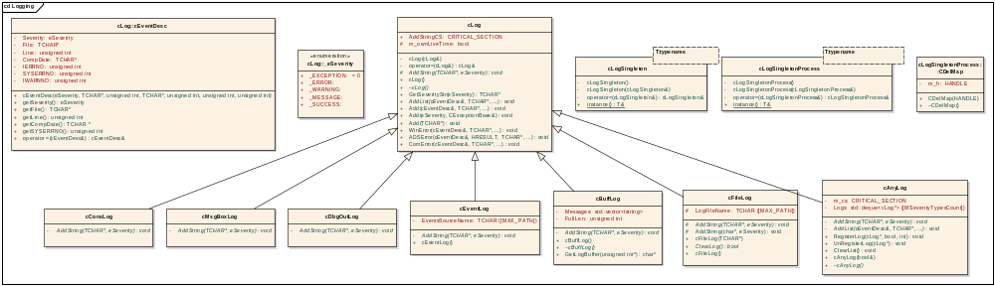

Logging environment variables

LOG_VERBOSITY – sets verbosity level for logging classes. Possible values:
- _NO_TRACE_ (or “0”)
- _TRACE_DEBUG_ (or “1”)
- _TRACE_STATES_ (or “2”)
- _TRACE_CALLS_ (or “3”)
Default verbosity level is _TRACE_DEBUG_.

LOG_FORMAT – sets format of log messages. Possible values:
- _FMT_TEXT_ (or “0”) – simple test format
- _FMT_CSV_ (or “1”) – CSV format
Default log format is _FMT_TEXT_.

cAnyLog class gets values of these environment variables at creation. If variable does not exist then default value will be used.

Logging defines

SKIP_CRT_EXCEPTION_HOOK – disables handling SEH and C++ exceptions (not defined by default)

Tracing macroses

DISABLE_TRACE – disables tracing from current place (for current thread)
ENABLE_TRACE – enables tracing from current place (for current thread)

Net Log

Client
Responsibility of client part is to reply on server’s UDP announce requests, and to accept server TCP connections. Once TCP connection to server established, client start to send logging stuff to server.
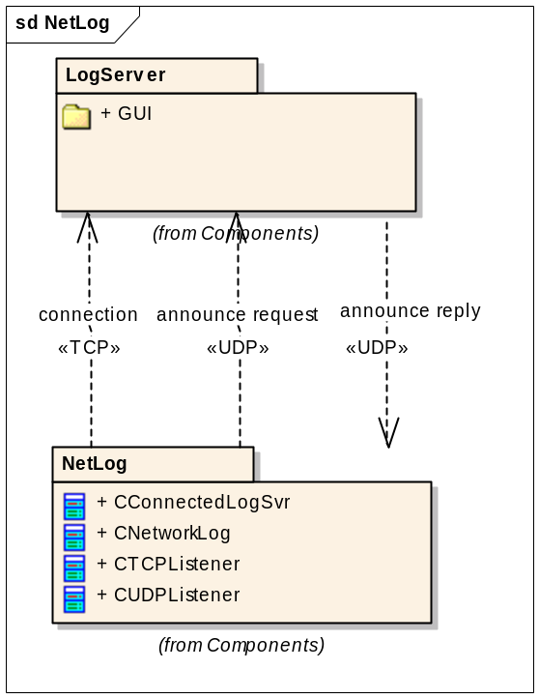
Detailed class definitions for net log could be found at NetLog.eap document.

Class diagram
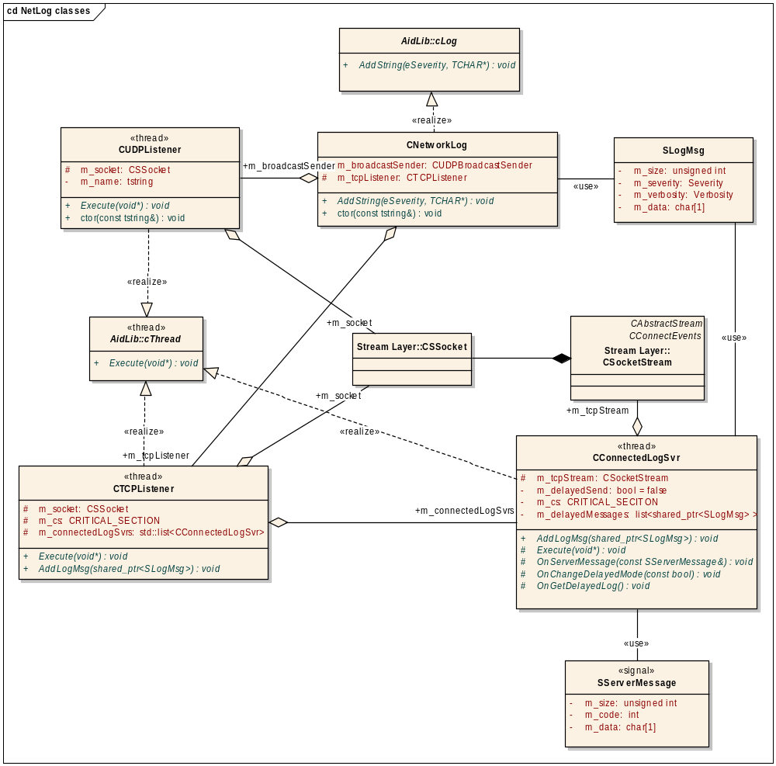

Add log message diagram
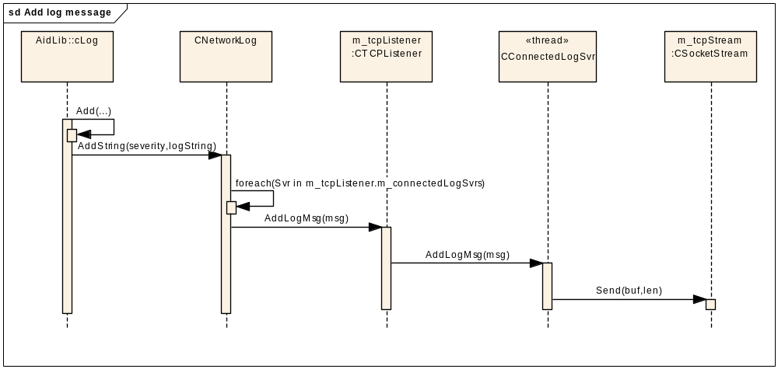

Handle server command (GetDelayedLog) diagram
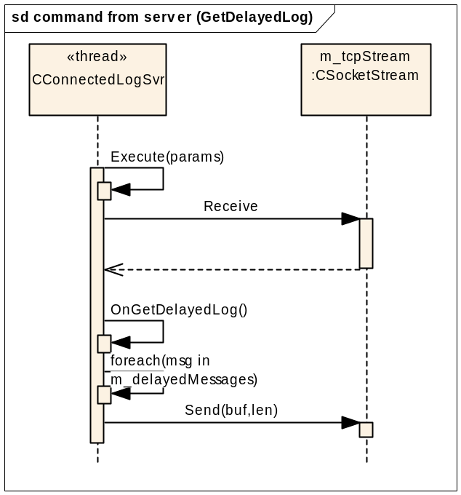

NetLog environment variables

NetLog allows receiving log messages which logged before connection with a log viewer established. CNetworkLog class gets the value of NETLOG_SHOW_PRESTORED_MESSAGES environment variable at creation.

NETLOG_SHOW_PRESTORED_MESSAGES - environment variable which allows viewing of pre-stored log messages. Possible values:
“1” – enables store log messages before connection with a log viewer established,
“0” – disables store log messages before connection with a log viewer established.

Storing log messages is disabled by default. If environment variable does not exist then default value will be used.

Server
TODO: add description and overall architecture

Class diagram
TODO: add class diagram

